**Calculator Documentation**

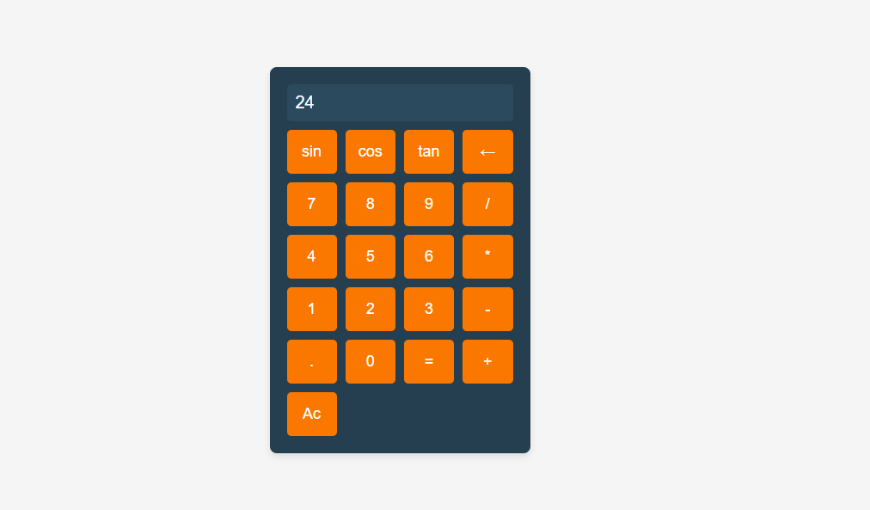

**Introduction**

The calculator is a web-based tool that allows users to perform basic arithmetic operations and trigonometric functions. It provides a simple and intuitive interface for users to input expressions and obtain results instantly.

**Features**

- Basic arithmetic operations: addition, subtraction, multiplication, and division.

- Trigonometric functions: sine, cosine, and tangent.

- Clear button to reset the input field.

- Backspace button to delete the last character entered.

- Responsive design for optimal viewing and interaction across devices.

**HTML Structure**

The calculator interface is structured using HTML elements, including text input fields and buttons. The layout is designed to be visually appealing and user-friendly, with appropriate spacing and styling for ease of use.

**CSS Styling**

CSS styles are applied to enhance the appearance of the calculator interface. The styling includes background colors, button designs, animations for transitions, and responsive layout adjustments. The design choices aim to create a modern and attractive user interface.

**JavaScript Functions**

JavaScript functions are used to handle user interactions and perform calculations based on input expressions. These functions enable dynamic updating of the input field and provide real-time feedback to the user. The calculator logic ensures accurate computation and error handling for invalid inputs.

`**handleButtonClick`**

- Event listener function that responds to button clicks and updates the input field accordingly.

`evaluateExpression`

- Function to evaluate the input expression and compute the result using JavaScript's `eval` function.

`clearInput`

- Function to clear the input field when the "Ac" (All Clear) button is clicked.

`deleteCharacter`

- Function to delete the last character entered in the input field when the backspace button is clicked.

`calculateTrigonometric`

- Functions to calculate trigonometric functions (sine, cosine, tangent) of the input angle in degrees.

**Event Listeners**

Event listeners are attached to each button element to capture user clicks and trigger the corresponding actions. These listeners ensure that user interactions are properly handled and processed by the calculator logic.

**Conclusion**

The calculator provides a convenient and efficient tool for performing arithmetic and trigonometric calculations. With its responsive design, intuitive interface, and accurate computation capabilities, users can quickly obtain results and carry out mathematical operations with ease. Whether for simple calculations or complex trigonometric functions, the calculator offers a versatile solution for various mathematical tasks.